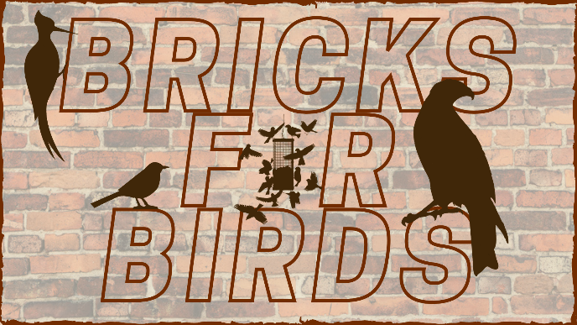
Bricks for Birds Order Form
□ 4” x 8” Text Only Brick
□ 8” x 8” Text Only Brick
□ 4” x 8” Text/Graphic Brick
□ 8” x 8” Text/Graphic Brick
Contact Information
Name _____________________________________________
You can honor a family member, friend, organization, or business by purchasing a 4" x 8" or 8" x 8" brick to be part of the landscape of our bird display behind the West Wing of the Interpretive Building. Order your brick with text engraving of your choice--you can even include one of several graphics such as a butterfly or bird silhouette. Your brick will be installed in the path of the bird display (a.k.a. Pollinator Parkway) starting in Spring of 2021. The funds raised through this project will help feed all of the neighborhood birds that live here and support the maintenance of the display. What a wonderful holiday gift! Call 319-277-2187 with any questions.
Address ___________________________________________
City, State, Zip ______________________________________
Telephone _________________________________________
Email Address_______________________________________

Billing Information (If different than above)
Name______________________________________________
Address ____________________________________________
City, State, Zip _______________________________________
Telephone __________________________________________
Email Address_______________________________________
Payment
Payment for your brick can be made by cash, check or credit card. If you would like to pay by credit card, please stop into the Nature Center or call us at 319-277-2187. Please make checks out to “Black Hawk County Conservation.” In the Memo line, please write “Bricks for Birds.” Your brick order will not be processed until payment is received.
Hartman Reserve Nature Center
Black Hawk County Conservation
657 Reserve Drive
Cedar Falls, Iowa 50613

Graphic Options for Text/Graphic Bricks
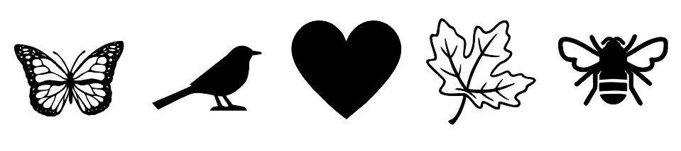

Text Only Bricks

4” x 8” Brick Inscription ($75)
Please print one letter per box. Spaces count as a character. Bricks will be engraved with what is put in the boxes below. 15 characters per line.
[___]___]___]___]___]___]___]___]___]___]___]___]___]___]___]
[___]___]___]___]___]___]___]___]___]___]___]___]___]___]___]
[___]___]___]___]___]___]___]___]___]___]___]___]___]___]___]
8” x 8” Brick Inscription ($125)
Please print one letter per box. Spaces count as a character. Bricks will be engraved with what is put in the boxes below. 15 characters per line.
[___]___]___]___]___]___]___]___]___]___]___]___]___]___]___]
[___]___]___]___]___]___]___]___]___]___]___]___]___]___]___]
[___]___]___]___]___]___]___]___]___]___]___]___]___]___]___]
[___]___]___]___]___]___]___]___]___]___]___]___]___]___]___]
[___]___]___]___]___]___]___]___]___]___]___]___]___]___]___]
[___]___]___]___]___]___]___]___]___]___]___]___]___]___]___]

Text & Graphic Bricks

4” x 8” Graphic Brick Inscription ($100)
Please print one letter per box. Spaces count as a character. Bricks will be engraved with what is put in the boxes below.

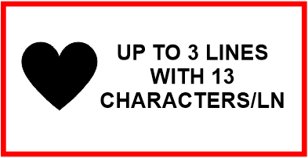
[___]___]___]___]___]___]___]___]___]___]___]___]___]
[___]___]___]___]___]___]___]___]___]___]___]___]___]
[___]___]___]___]___]___]___]___]___]___]___]___]___]

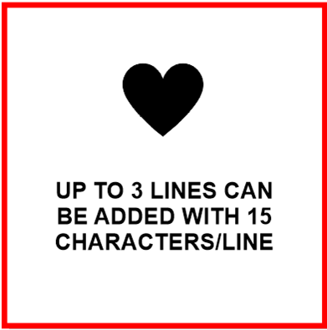
8” x 8” Graphic Brick Inscription ($175)
Please print one letter per box. Spaces count as a character.
Bricks will be engraved with what is put in the boxes below.

[___]___]___]___]___]___]___]___]___]___]___]___]___]
UP TO 3 LINES CAN
BE ADDED WITH 13
CHARACTERS/LINE
[___]___]___]___]___]___]___]___]___]___]___]___]___]
[___]___]___]___]___]___]___]___]___]___]___]___]___]

Please check which graphic you’d like on your brick (choose one): □ Heart □ Butterfly □ Bee □ Leaf □ Bird

